Issues observed in App:

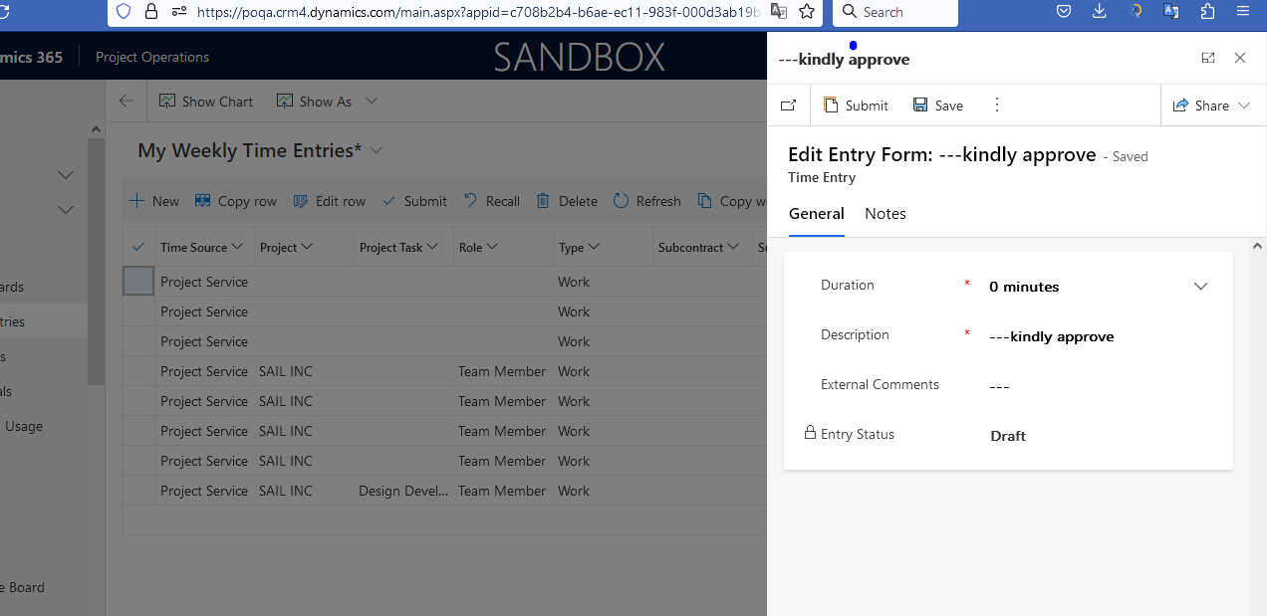

--A time entry is created for 0 minutes.

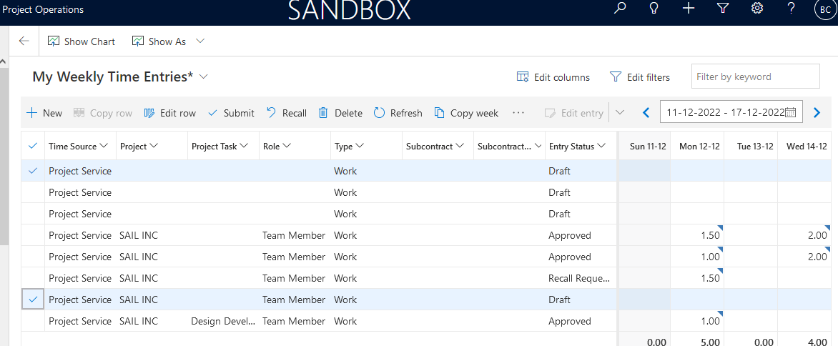

--Recall is active for Draft entry, however not clickable

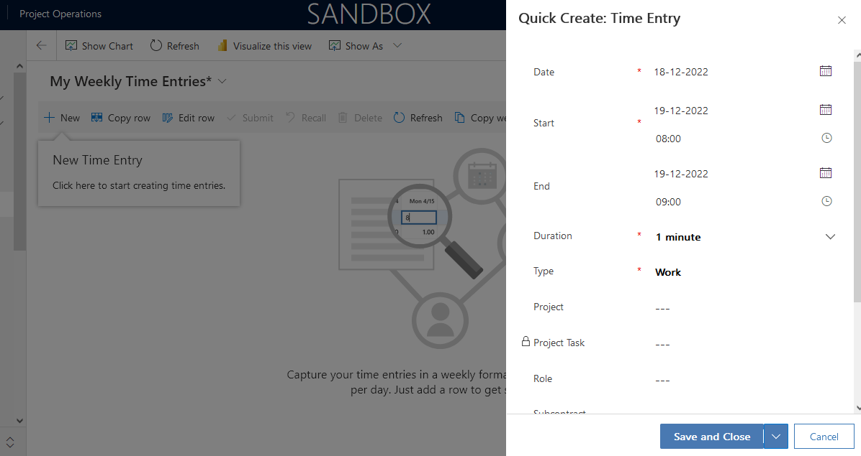

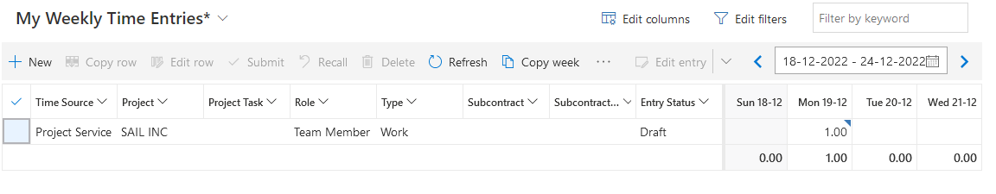

--Able to create backward records even in the next year

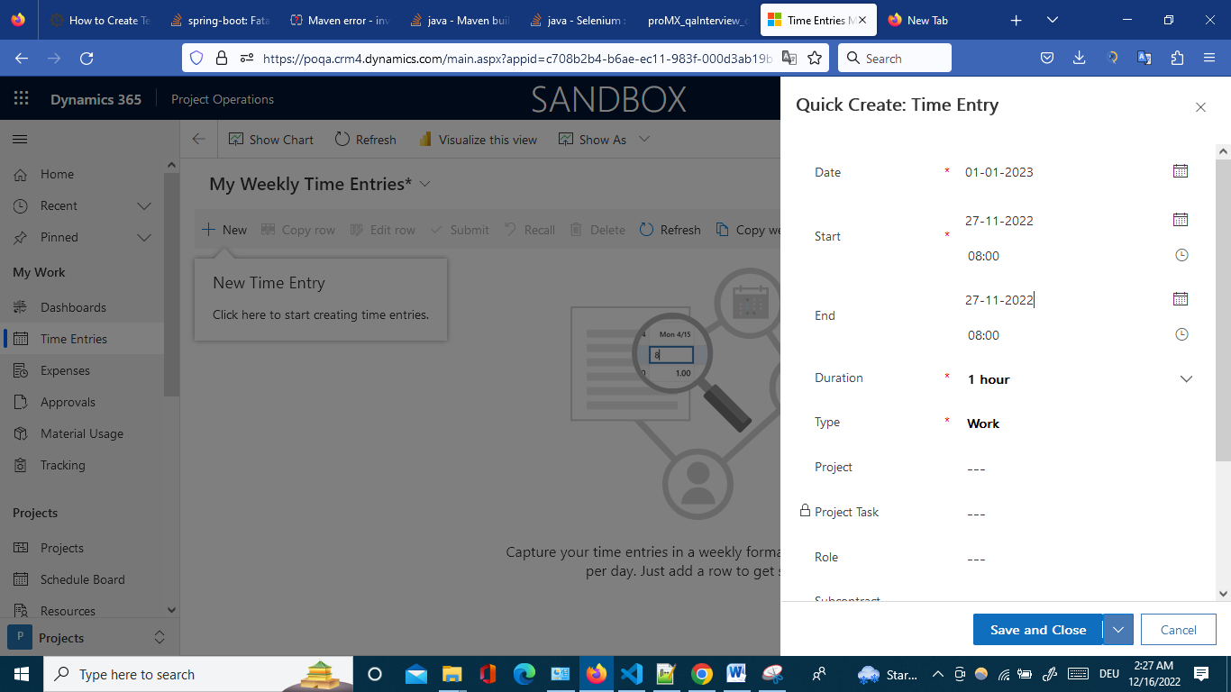

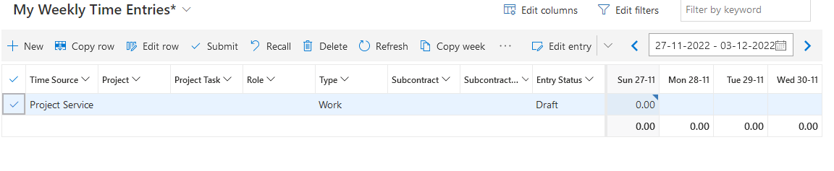

New Entry is created for the last year,on next year.